**Team:** Green

**Group Members:** Maurice Farr, Hajot Singh, Ann Chen, Ryan Engelken, and Emmanual Akinseye

**Date:** May 7, 2025

**Validation Testing & Screenshots**

* **Website Homepage/Frontpage**

It provides a selection of colleges to consider, along with various location options like restaurants and study spots.

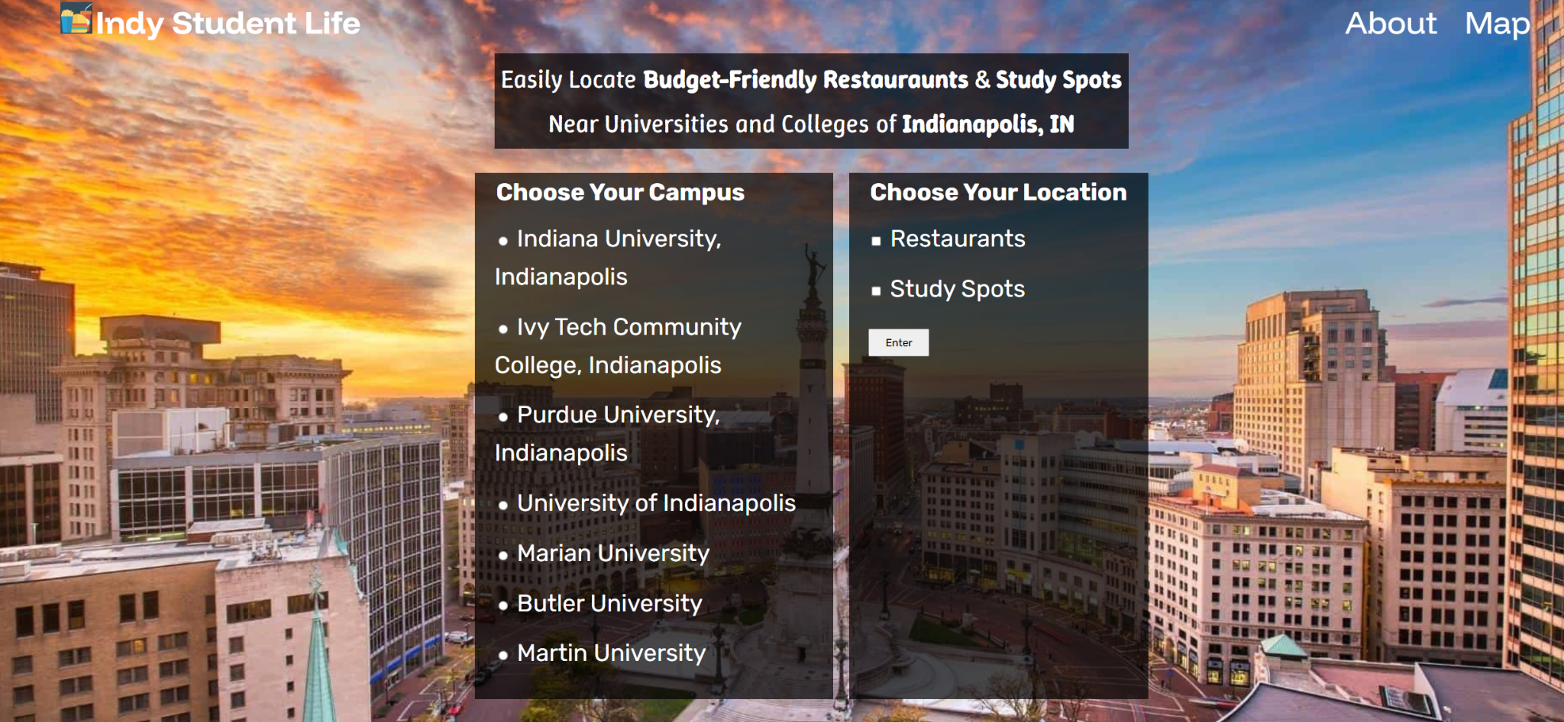

* **Homepage Categories**

The homepage includes three main sections: "About," "Map," and "Indy Student Life Logo."

* **Indy Student Life Logo**

To return to the homepage, simply click on the Indy Student Life logo.



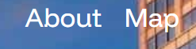

* **Selecting Your Campus**

Only one campus can be selected at once.



* **Choosing Your Location**

When selecting your locations, you can opt for one or both choices simultaneously. The available options include restaurants and study spots.



* **Validation Testing**

If a user tries to access restaurants or study spots without selecting a campus, an error message will appear, prompting them to make a selection.

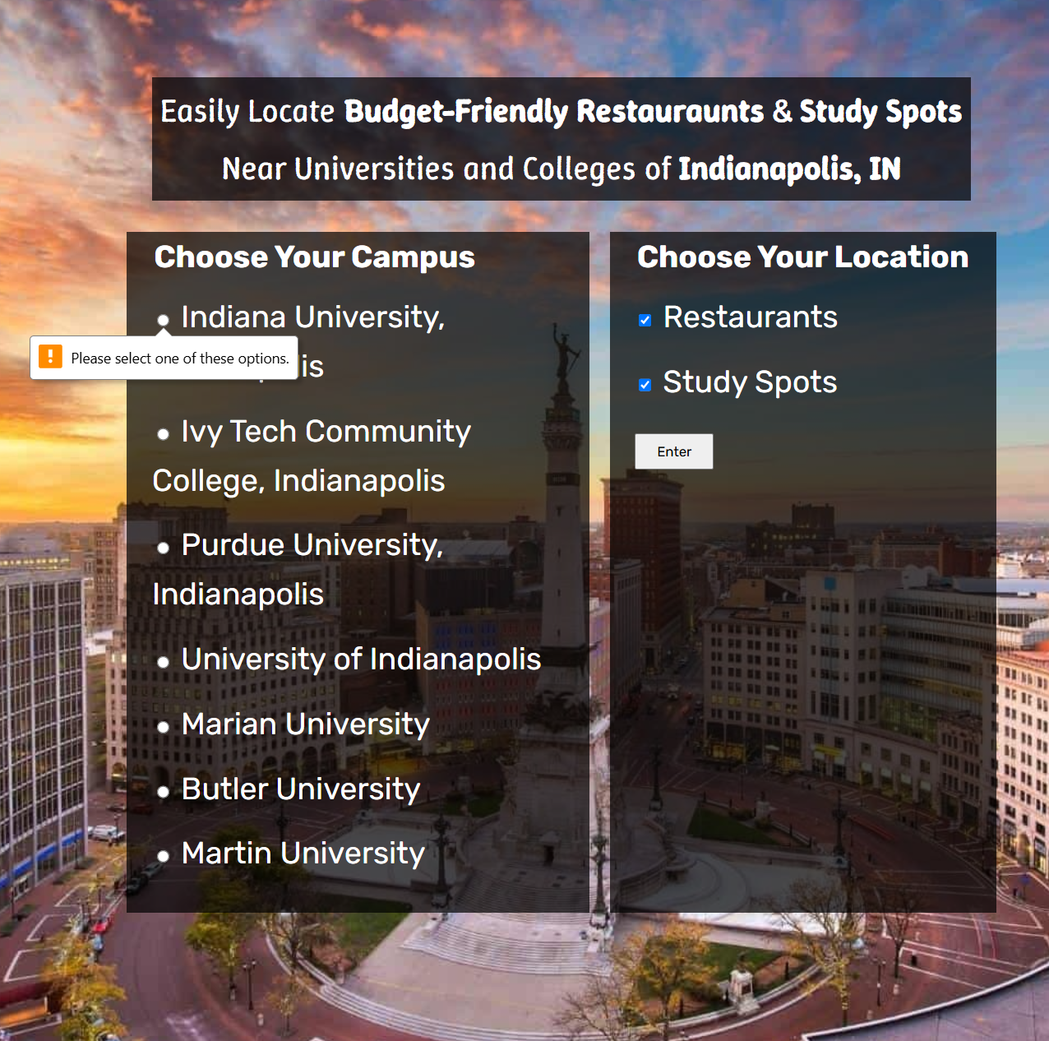

* **Map Displaying Icons**

After choosing your campus and selecting from the available locations, such as restaurants and study areas, click on enter. This action will bring up a map displaying icons representing the campus, restaurants, and study spots.

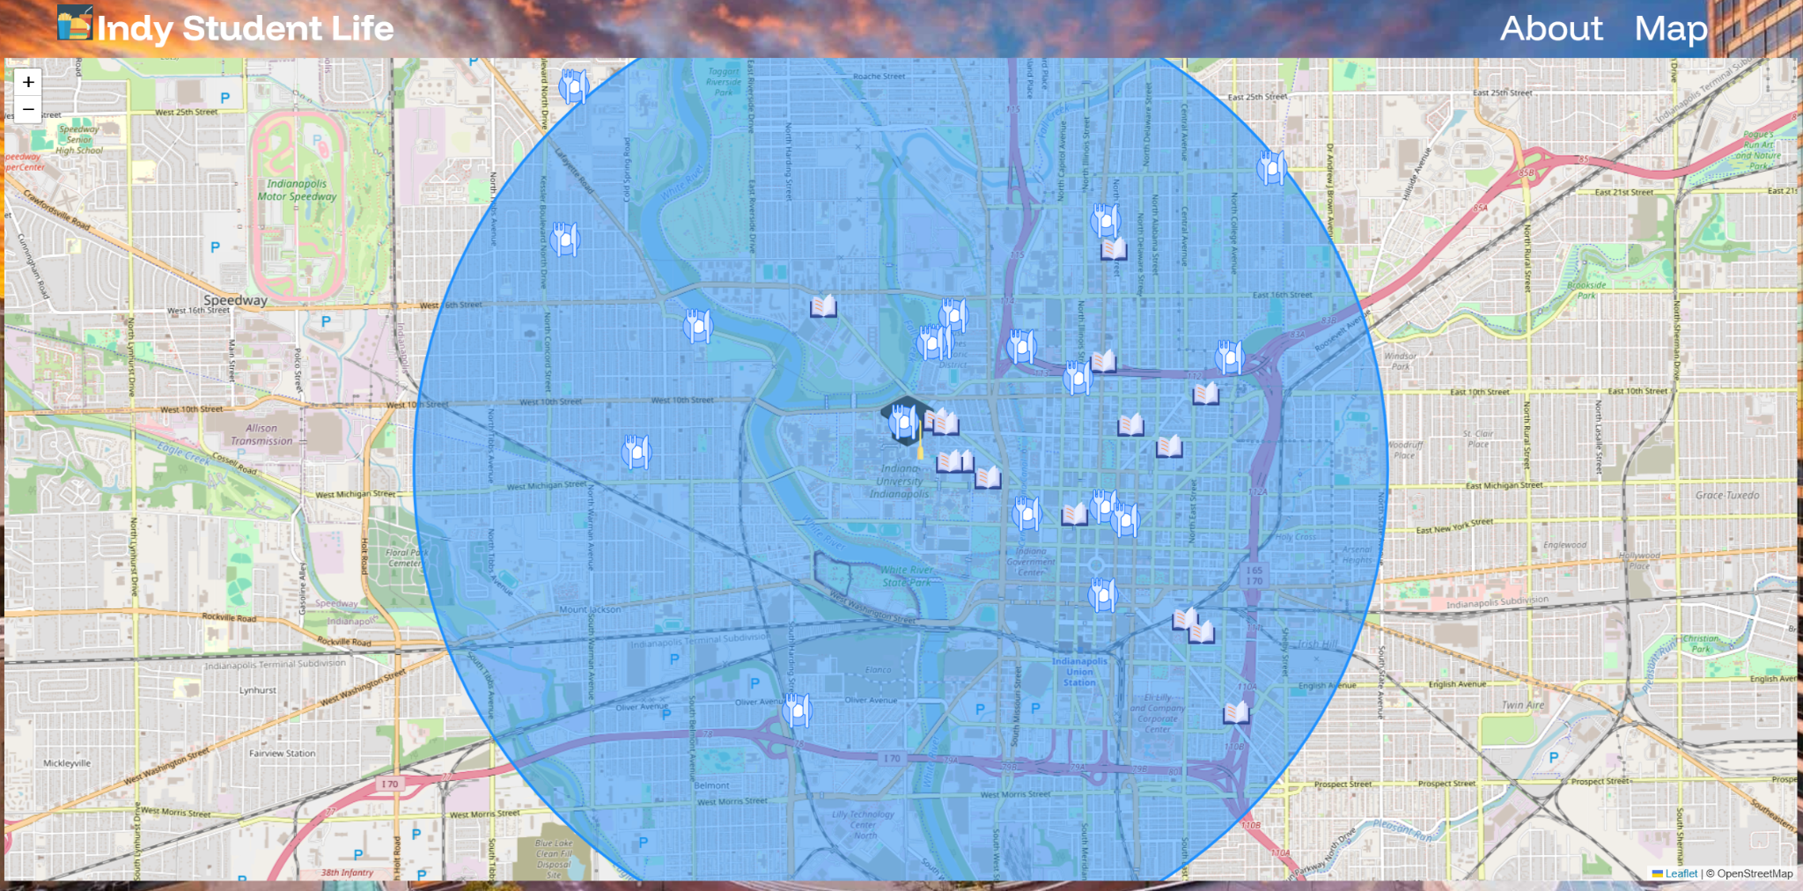



* **The “About” Page**

The "About" page offers a summary of the website project, outlining its primary objectives, information about the class course, and details regarding the associated college, Ivy Tech. It also introduces the team members who contributed to the project and emphasizes the technological elements employed throughout the initiative.

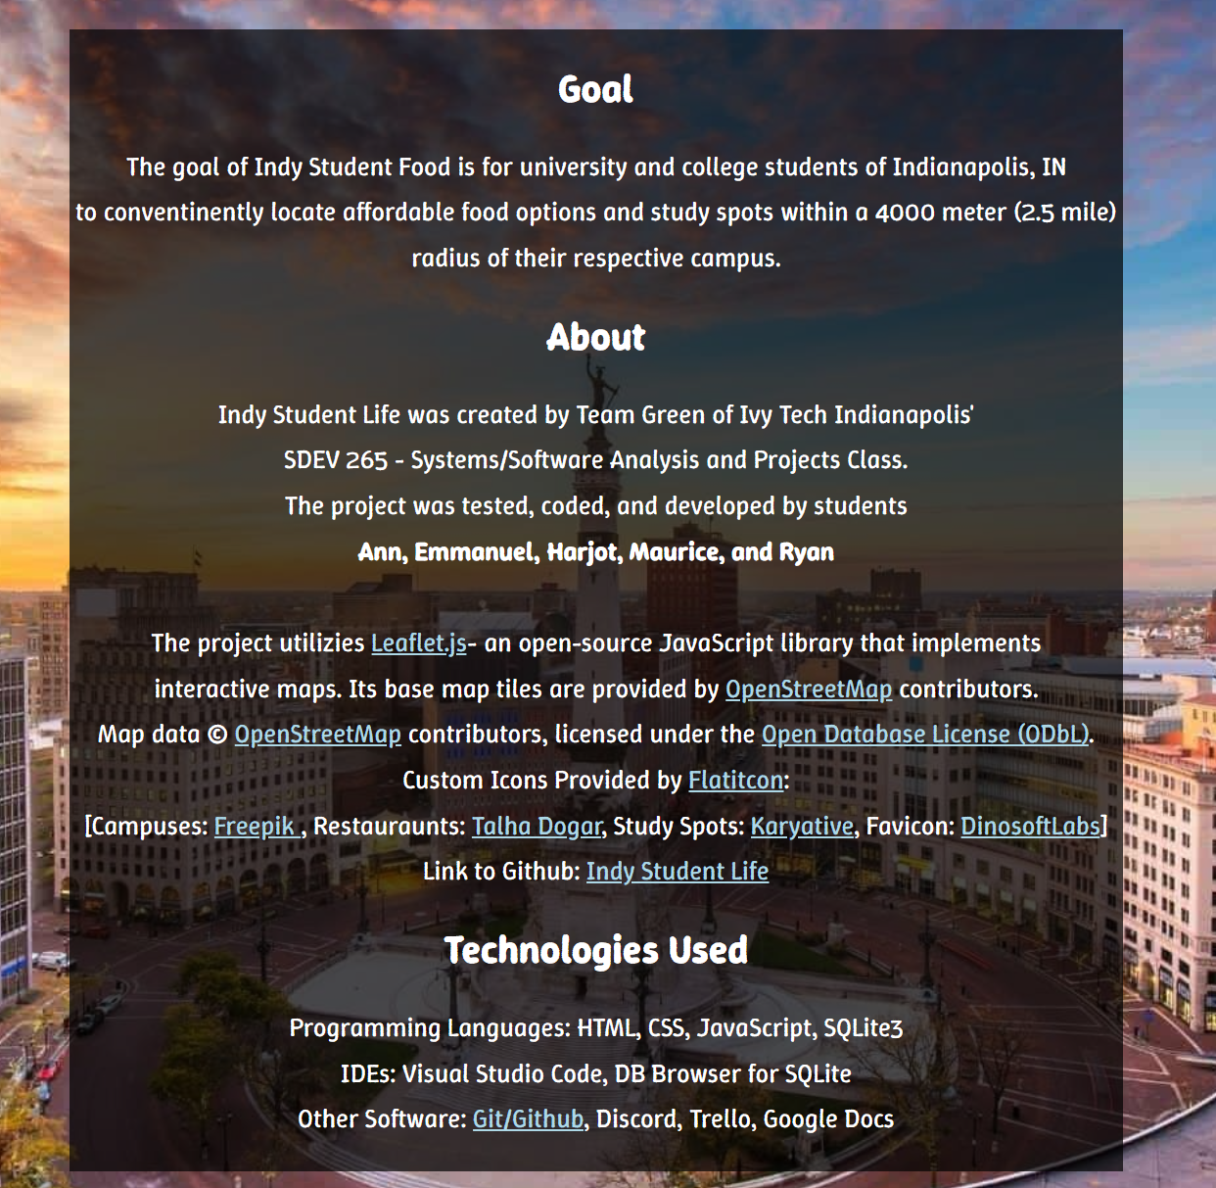

* **The “Map” Page**

The Map Page displays the state of Indiana, enabling users to navigate the region with ease. Additionally, users can zoom in and out to examine specific areas more closely.

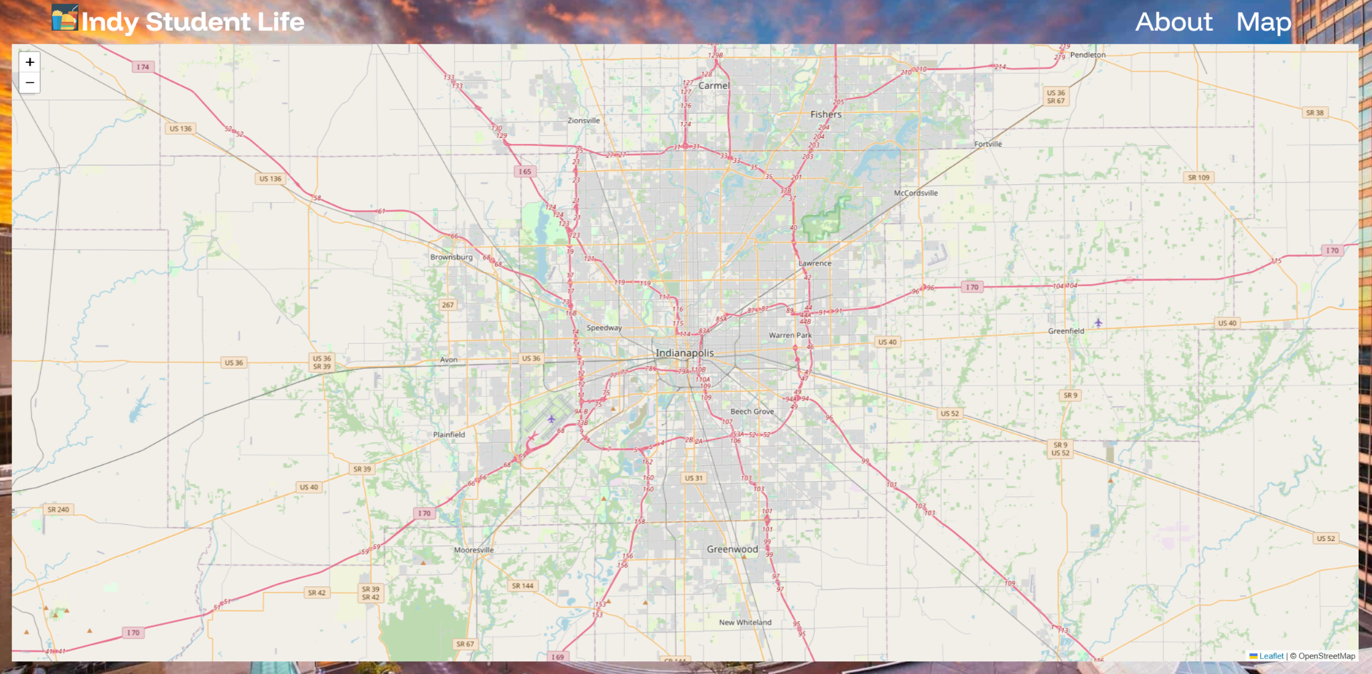

* **Icon For Restaurant Example**

Clicking on the restaurant icon will show information about the chosen restaurant, along with a link to its website that you can access by clicking on it.



* **Icon For Study Spot Example**

Clicking on the study spot icon will show information about the chosen study spot, along with a link to its website that you can access by clicking on it.

